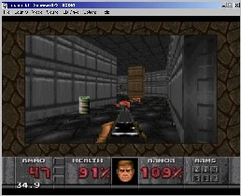
Fusion(formerly known as "Kega II" and Kega Fusion) is a Sega SG1000, SC3000, Master System, Game Gear, Genesis/Megadrive, SegaCD/MegaCD and 32X emulator for Win9x/ME/2000/XP.

